PATTERNS TO CROCHET ROBIN AND REINDEER FOR CHOC ORANGE

I used acrylic DK and a 4mm hook (I hooked quite tightly for this, so you may find you need to go down to a 3.5mm depending on your tension. When it is finished, it should be quite a struggle to get it over the top of the chocolate orange - but it will go! And then it will sit nice and snug at the bottom)
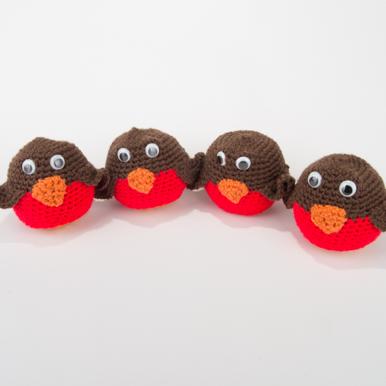

Robin
Body:
With brown yarn:
Round 1: 6 dc into Magic Circle
Round 2: 2dc into each stitch (12 stitches)
Round 3: 1dc into first stitch, 2dc into next stitch, repeat to end (18 stitches)
Round 4: 1dc, into first two stitches, 2dc into next stitch, repeat to end (24 stitches)
Round 5: 1dc into first three stitches, 2dc into next stitch, repeat to end (30 stitches)
Round 6: 1dc into first four stitches, 2dc into next stitch, repeat to end (36 stitches)
Round 7-11: 1dc into each stitch (36 stitches)
Change to Red
Round 12-17: 1dc into each stitch (36 stitches)
Round 18: 1dc into first four stitches, dc2tog, repeat to end (30 stitches)
Round 19: 1dc into first three stitches, dc2tog, repeat to end (24 stitches)
Round 20: 1dc into each stitch (24 stitches)
Fasten off

The wings:
6dc into magic circle do no join together! Turn your work.
2 dc in each stitch (12 stitches). Turn
2 dc into each stitch, but missing last stitch (22 stitches). Turn
1dc into each stitch, but missing last stitch (21 stitches)
Fasten off
To attach the wings, spread the wing out so the 'V' lies flat along the join of the red and brown on the body. Whip stitch along with brown yarn and secure on the inside of the body. It will be a bit fiddly, but once you've sewn it on, the wing will then ruffle up nicely.
The beak:
Chain 6
Dc into each stitch (6 stitches). Turn
Dc, dc2tog, dc2tog, dc (4 stitches). Turn
Dc, dc2tog, dc.
Turn. Dc into final stitch
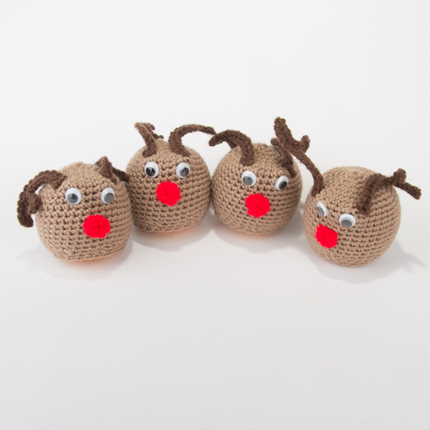

Reindeer
Body:
Round 1: 6 dc into Magic Circle
Round 2: 2dc into each stitch (12 stitches)
Round 3: 1dc into first stitch, 2dc into next stitch, repeat to end (18 stitches)
Round 4: 1dc, into first two stitches, 2dc into next stitch, repeat to end (24 stitches)
Round 5: 1dc into first three stitches, 2dc into next stitch, repeat to end (30 stitches)
Round 6: 1dc into first four stitches, 2dc into next stitch, repeat to end (36 stitches)
Round 7-17: 1dc into each stitch (36 stitches)
Round 18: 1dc into first four stitches, dc2tog, repeat to end (30 stitches)
Round 19: 1dc into first three stitches, dc2tog, repeat to end (24 stitches)
Round 20: 1dc into each stitch (24 stitches)
Fasten off.

Antler 1:
Chain 16
Dc into each stitch. Turn
Slip stitch in 2nd chain from hook, and then sl st into next 8 stitches
Chain 5, dc in 2nd ch from hook. Dc in next 3 st
sl st into next stitch on main branch of antler, then sl st to end.
Fasten off.

Antler 2:
Chain 16
Dc into each stitch. Turn
Slip stitch in 2nd chain from hook, and then sl st into next 4 stitches
Chain 5, dc in 2nd ch from hook. Dc in next 3 st
sl st into next stitch on main branch of antler, then sl st to end.
Fasten off.

