

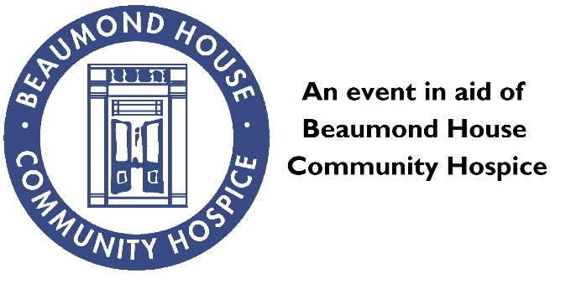

Registered Charity Number 1025442

**Contact Details**

**Date**

**Time**

**Venue**

**Price**

**FAMILY**

**FUN**

**DAY**