Chocolate Orange Cover ~ Snowman

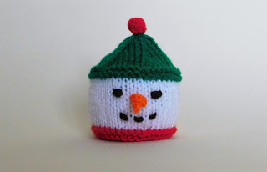
Snowman Chocolate Orange Cover

DK YARN

3.5mm knitting needles
Using Red ~

Cast on 43sts
Knit 2 rows
Change to White ~

Work 12 rows in stocking stitch (1row knit, 1 row purl)
Change to Green ~

Knit 4 rows
Work 2 rows in stocking stitch
Shape the top ~
Row 21: *K5, k2tog, repeat from * to last st, k1 (37sts)
Rows 22, 24, 26, 28, 30: S1, purl to last st, k1
Row 23: *K4, k2tog, repeat from * to last st, k1 (31sts)
Row 25: *K3, k2tog, repeat from * to last st, k1 (25sts)
Row 27: *K2, k2tog, repeat from * to last st, k1 (19sts)
Row 29: *K1, k2tog, repeat from * to last st, k1 (13sts)
Row 31: *K2tog, repeat from * to last st, k1 (7sts)
Cut off yarn, leaving a tail – thread the tail through the remaining 7sts, and pull up tight
Sew up the side seam, using the corresponding colour for each section.
Darn away ends
Add a bobble or a pompom on to the top of the hat
To make a bobble –
Bobble

Using red yarn cast on 3 stitches

Row 1: Knit in the front and back of every stitch (6sts)
Row 2: Purl
Row 3: Knit
Row 4: P2tog three times (3sts)
Cast off

Add a face ~
For the eyes – sew on two small black buttons (or use a length of black yarn)

For the mouth – use a length of black yarn and make 3 or 4 running stitches
For the nose – using a length of orange yarn ~
Cast on 4sts
K4,

K2tog, k2tog,
K2tog,

Fasten off

Sew on the nose, using the cast on and cast off tails

Fill with a Terry’s Chocolate Orange

